Choose Your Class Schedule Using Self-Service
(No login required) – See Self-Service Instructions at the bottom of this email or watch the video [Self Serivce Instructions].

How to View Your Current Schedule in Self-Service
- Log into Self-Service.
- Click on Academics (graduation cap icon).
- Select Student Planning.
- Click Plan & Schedule.
- Your current schedule should appear by default.
  - If you still see your previous schedule, use the right arrow (circled in red) to navigate to your current schedule.
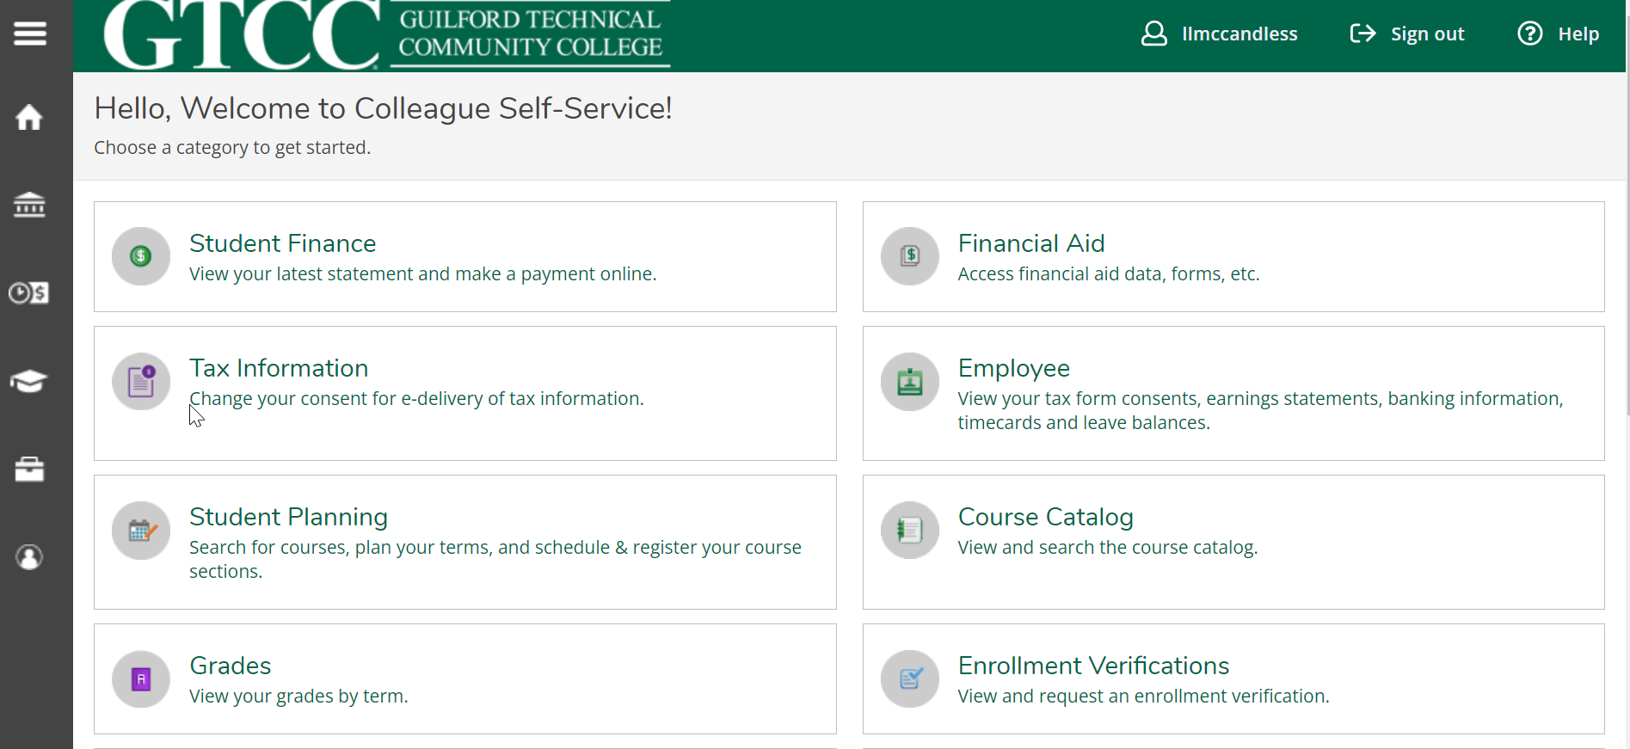
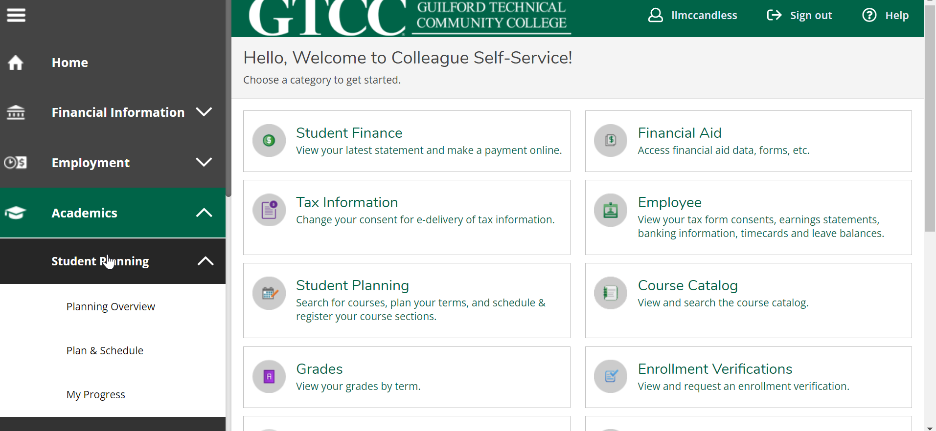
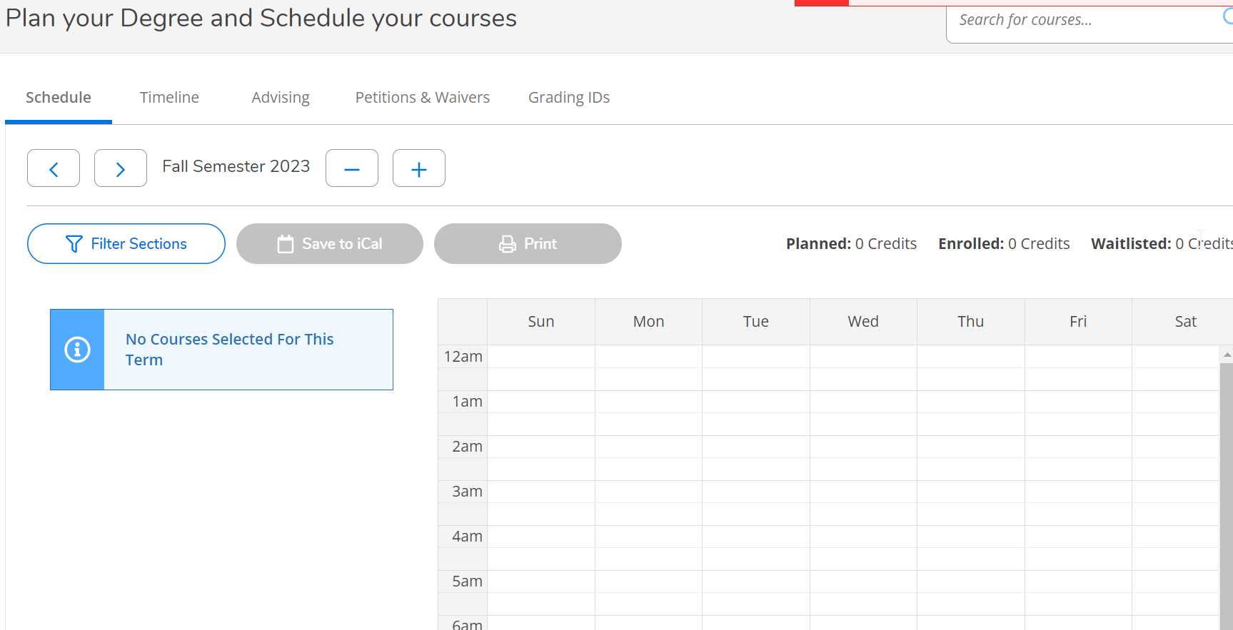

Important: Verify Your Schedule
After registering, please log into Self-Service and follow the steps to confirm that you are enrolled in the correct classes.
If you notice any errors or need to make changes, reply to your confirmation email or send an updated request to ccp@gtcc.edu as soon as possible.
Thank you,
Amber England
Administrative Assistant, Career and College Promise
GTCC
601 E. Main Street, Jamestown, NC 27282
Email: akengland@gtcc.edu
336.334.4822 ext. 50263
Mailing Address: PO Box 309, Jamestown NC 27282
www.gtcc.edu/ccp
Supporting success through innovative education, training, and partnerships
E-Mail correspondence to and from this address may be subject to the North Carolina Public Records Law and shall be disclosed to third parties when required by the statutes (G.S. 132-1.)

